Media Background

**Quick and simple: Manual entry of activities with the digital tachograph VDO DTCO 2.2**

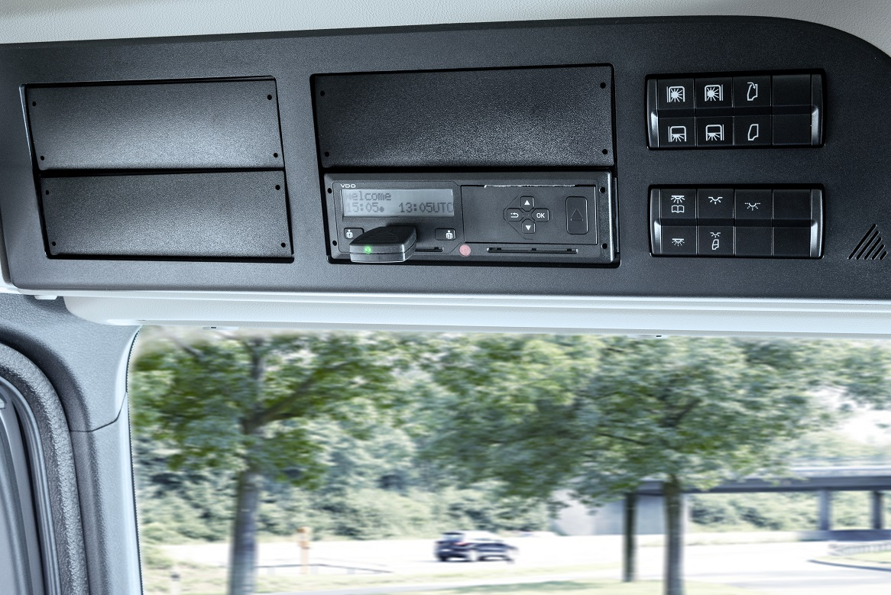

Step 1: Insert the VDO SmartLink Bluetooth dongle into the front interface of the DTCO and connect the tachograph with your smartphone via Bluetooth. If the connection is active, the green LED on the SmartLink will come on. Then insert the driver card. The welcome screen will be displayed (see photo).

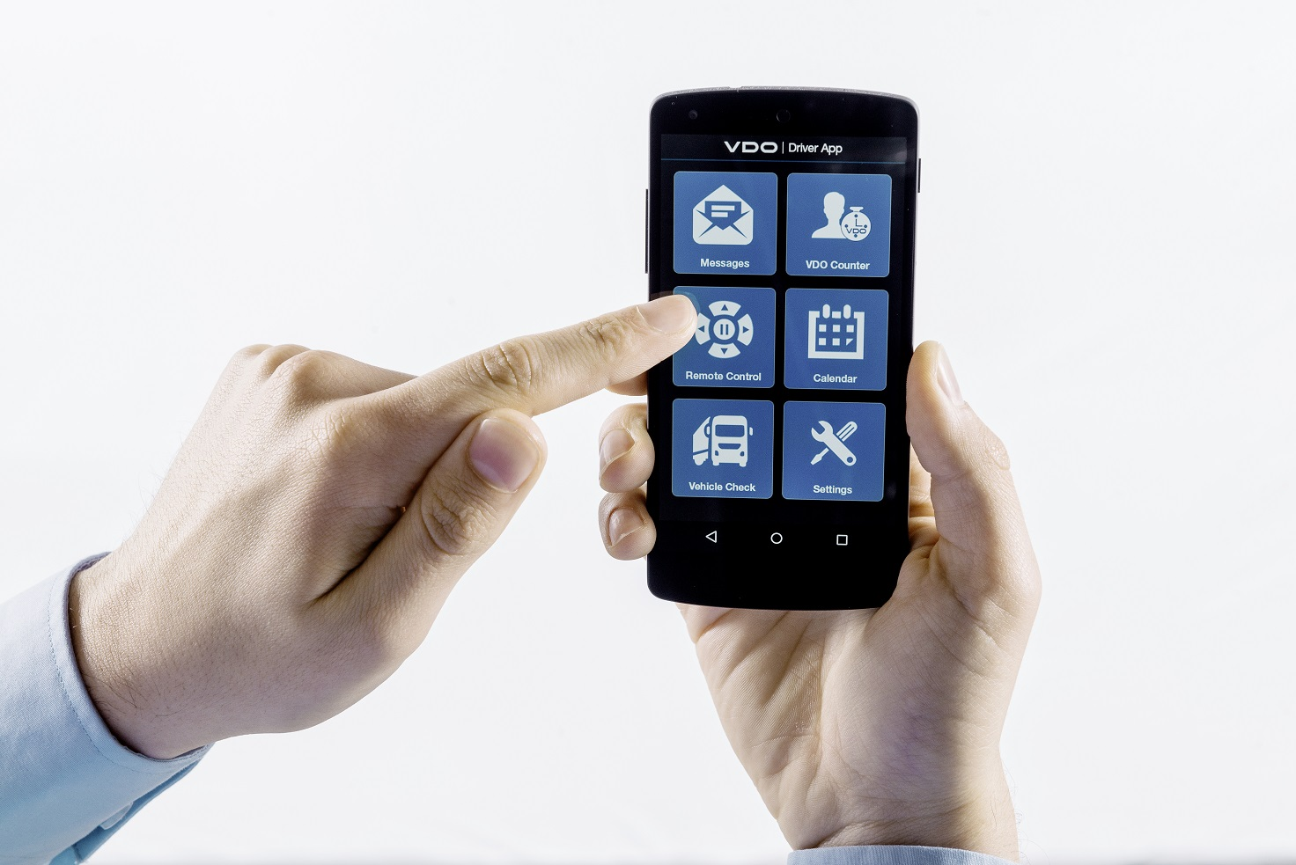

Step 2: Select the VDO Driver app and click on “Remote Control” in the overview menu.

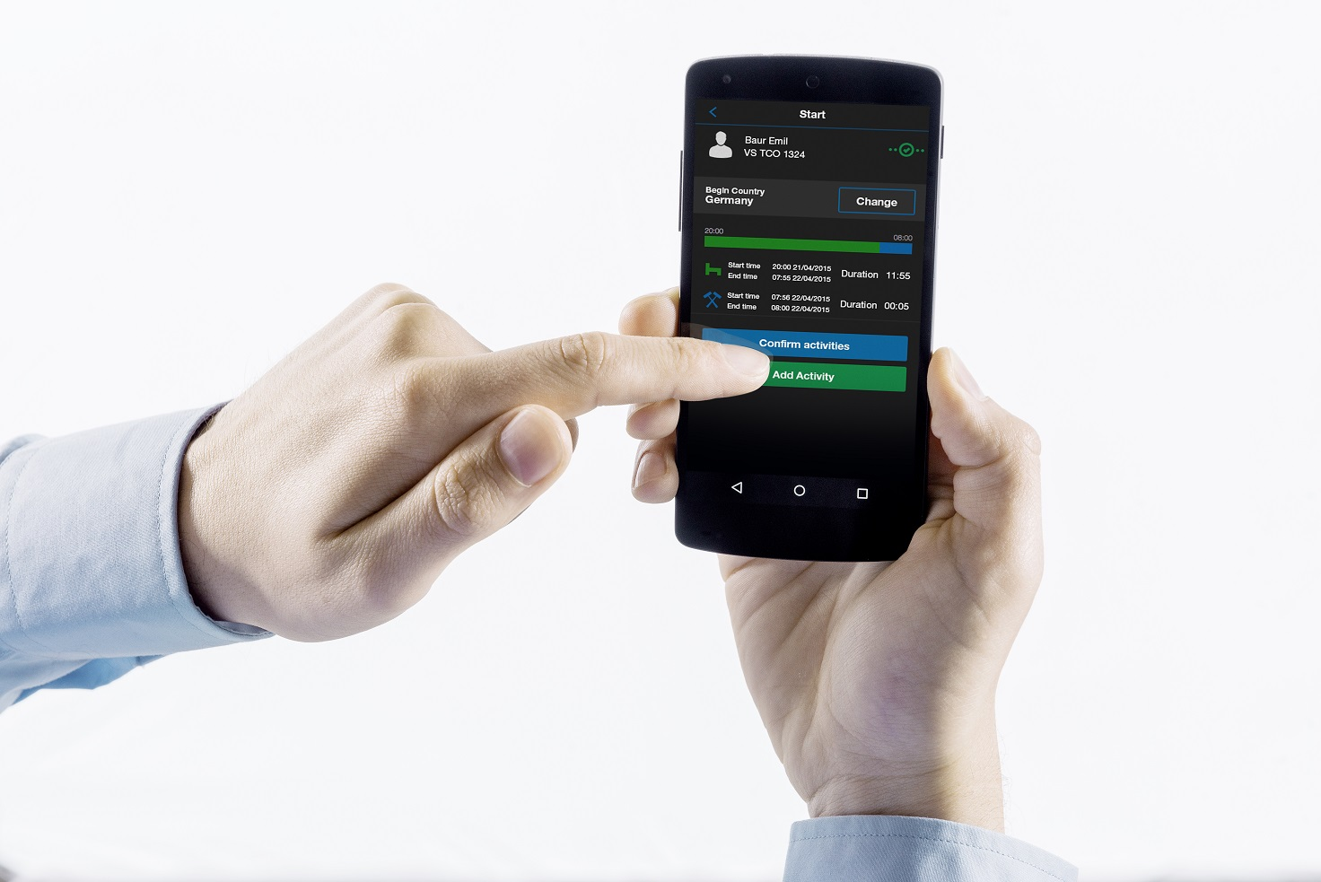

Step 3: The app automatically displays the missing time since the last card ejection. The last five minutes are indicated as working time by default, with the remaining time indicated as rest period.

The driver can change these entries, including the begin country setting, or save them to the DTCO 2.2 with “Confirm Activity”.

“Add Activity” creates new entries.

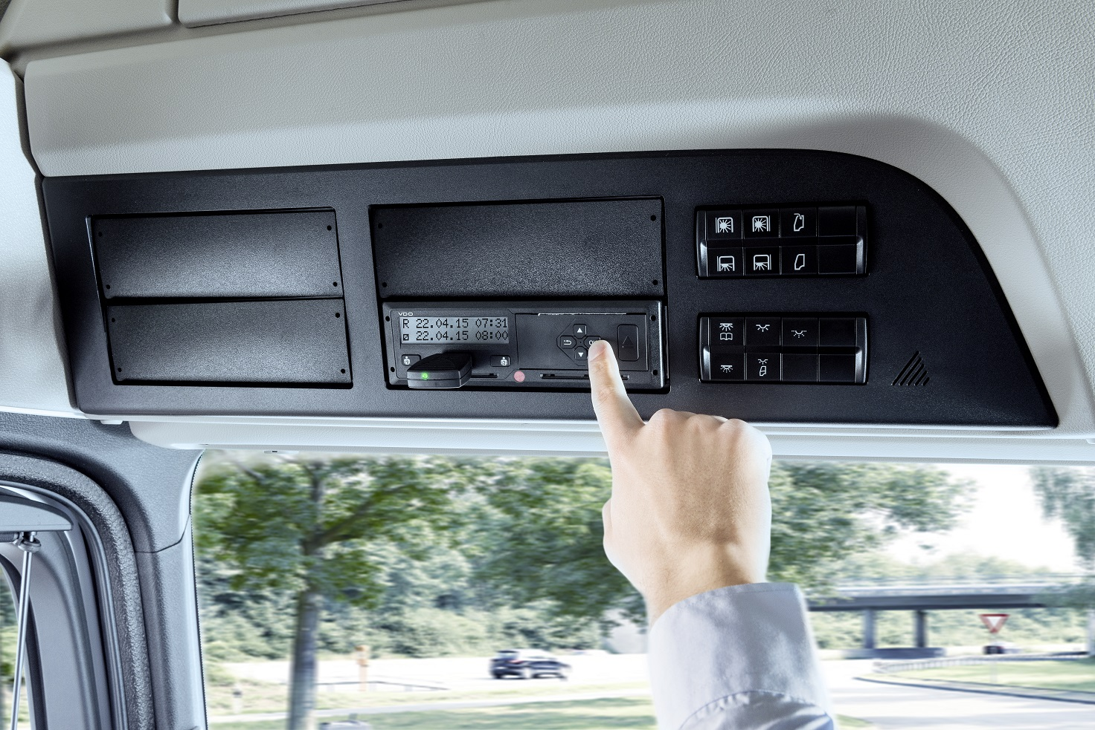

Step 4: Finally, confirm the DTCO entries by pressing the “OK” button.

**Continental** develops intelligent technologies for transporting people and their goods. As a reliable partner, the international automotive supplier, tire manufacturer, and industrial partner provides sustainable, safe, comfortable, individual, and affordable solutions. In 2014, the corporation generated preliminary sales of approximately €34.5 billion with its five divisions, Chassis & Safety, Interior, Powertrain, Tire, and ContiTech. Continental currently employs approximately 200,000 people in 53 countries.

Information management in and beyond the vehicle is at the very heart of the **Interior** division. The product portfolio for different types of vehicles includes: instrument clusters, multifunctional and head-up displays, control units, access control and tire-information systems, radios, infotainment systems, input devices, control panels, climate control units, software, cockpits as well as services and solutions for telematics and Intelligent Transportation Systems. The Interior division employs more than 36,000 people worldwide and generated preliminary sales of approximately €7 billion in 2014.

Within the Interior Division the **Commercial Vehicles & Aftermarket** Business Unit accommodates the specific requirements of the commercial vehicle, special vehicle and aftermarket sector. A global network of sales and service companies ensures proximity to local customers. Covering the product brands Continental, VDO, ATE, Galfer and Barum, the Business Unit offers electronic products, systems and services for commercial and special vehicles, a broad selection of products for specialized workshops and spare parts for the Independent Aftermarket and Original Equipment Services after end of series production of the vehicle manufacturer.

Contact for Journalists

Christopher Schrecke

Head of Media Relations and Internal Communications  
Commercial Vehicles & Aftermarket

Phone: +49 69 7603-2022

E-mail: [christopher.schrecke@continental-corporation.com](mailto:christopher.schrecke@continental-corporation.com)

This document is available in the following languages: German, English

Links

**Online press portal:** www.continental-presse.de www.continental-presse.de

**Media database:** www.continental-mediacenter.com

**Video portal:** videoportal.continental-corporation.com